Final Project Submission

Part 1: Your Project (Whatever State It's In)
Upload everything related to your project to your repository's project/ folder:
- Your prompts — The actual prompts you used (copy/paste from your AI conversations)
This the last troubleshoot to all the agents work locally
creating another chatbot agent to tutor students on IPv4 subnetting. This should be like the subnetting tutor. Used the attached Python code as a template of code that works in Spyder IDE. Then use the training videos to see the process the students see. then the quiz questions that the agent tutors students to answer. There should be five levels of help with the last level giving the answers with explanation.

This is the final application but is not working
https://github.com/JoePhillippe/JoePhillippe/ PROMPTS.md

- Your outputs — What the AI generated (screenshots, text files, code, images, etc.)
- Any iterations — Show how your approach evolved over time
I created a different project in Claude for each sprint.
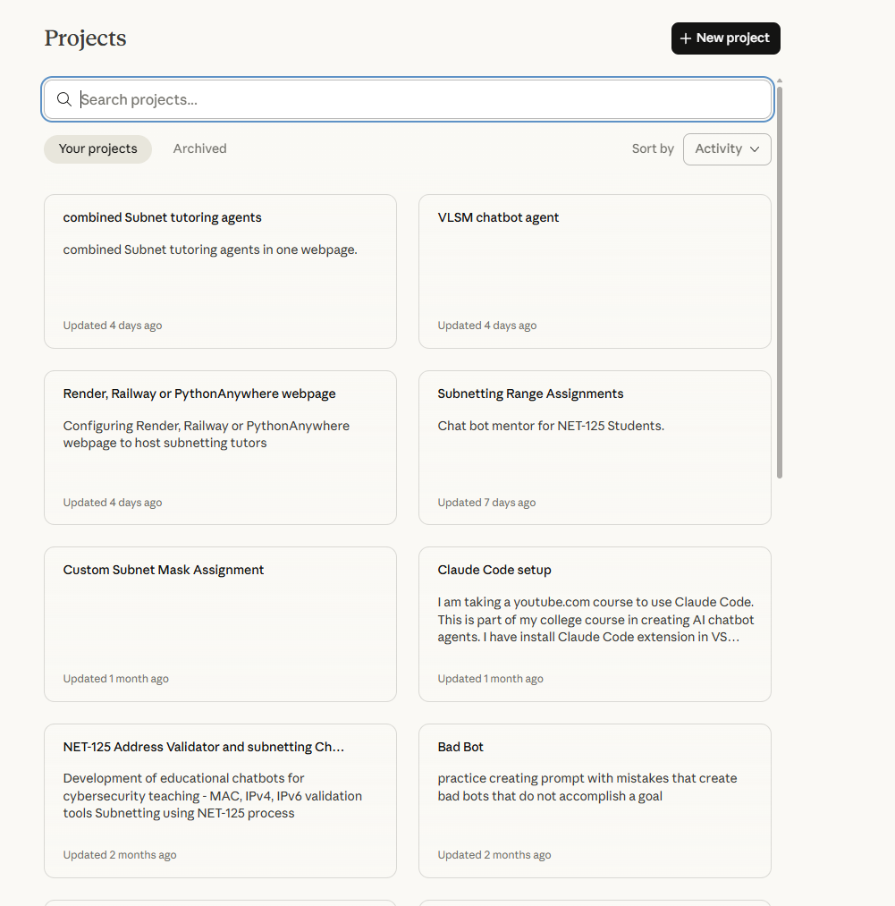
- A working demo (if applicable) — Could be a link, a screenshot walkthrough, or exported files

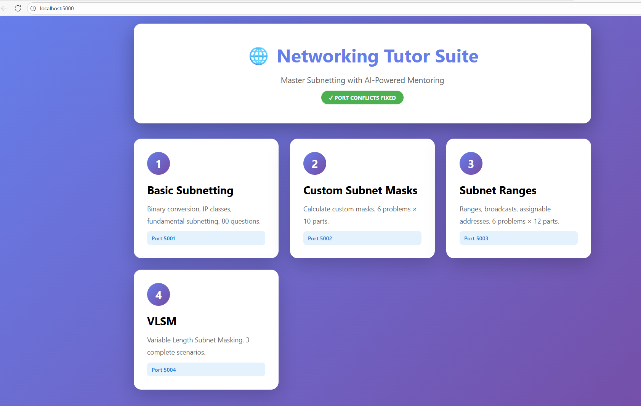
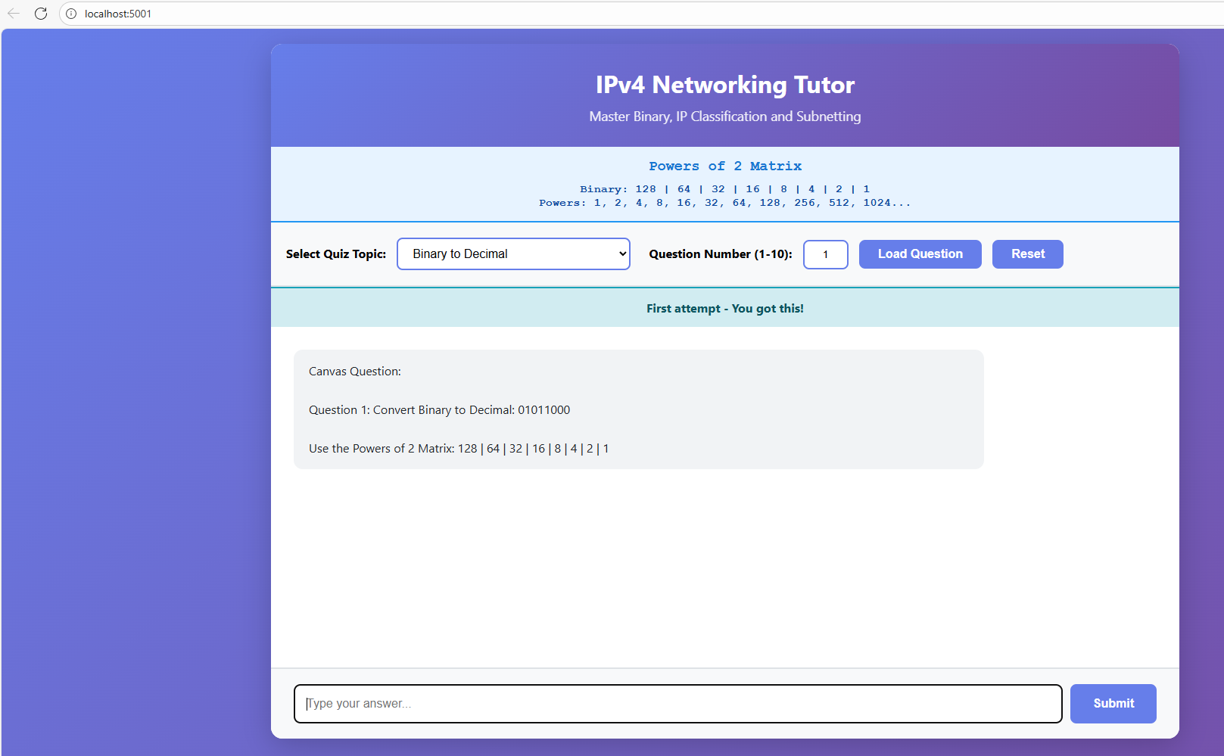
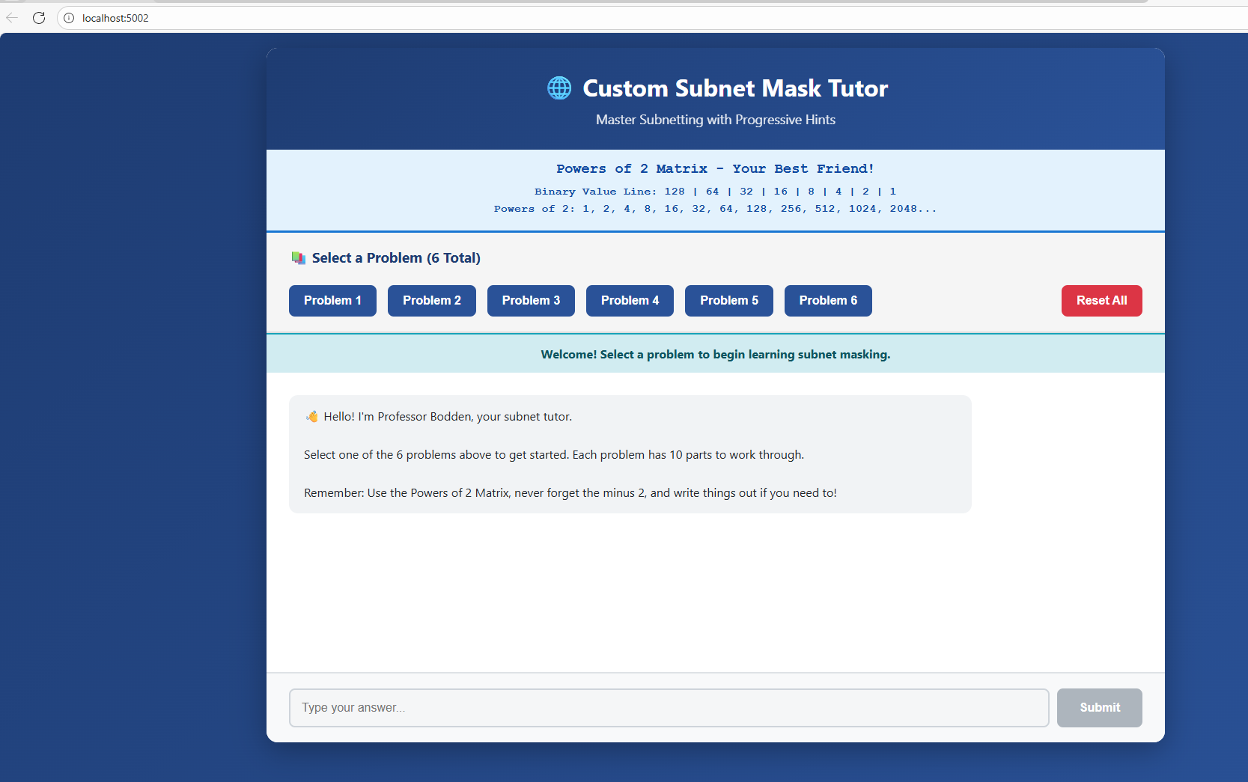
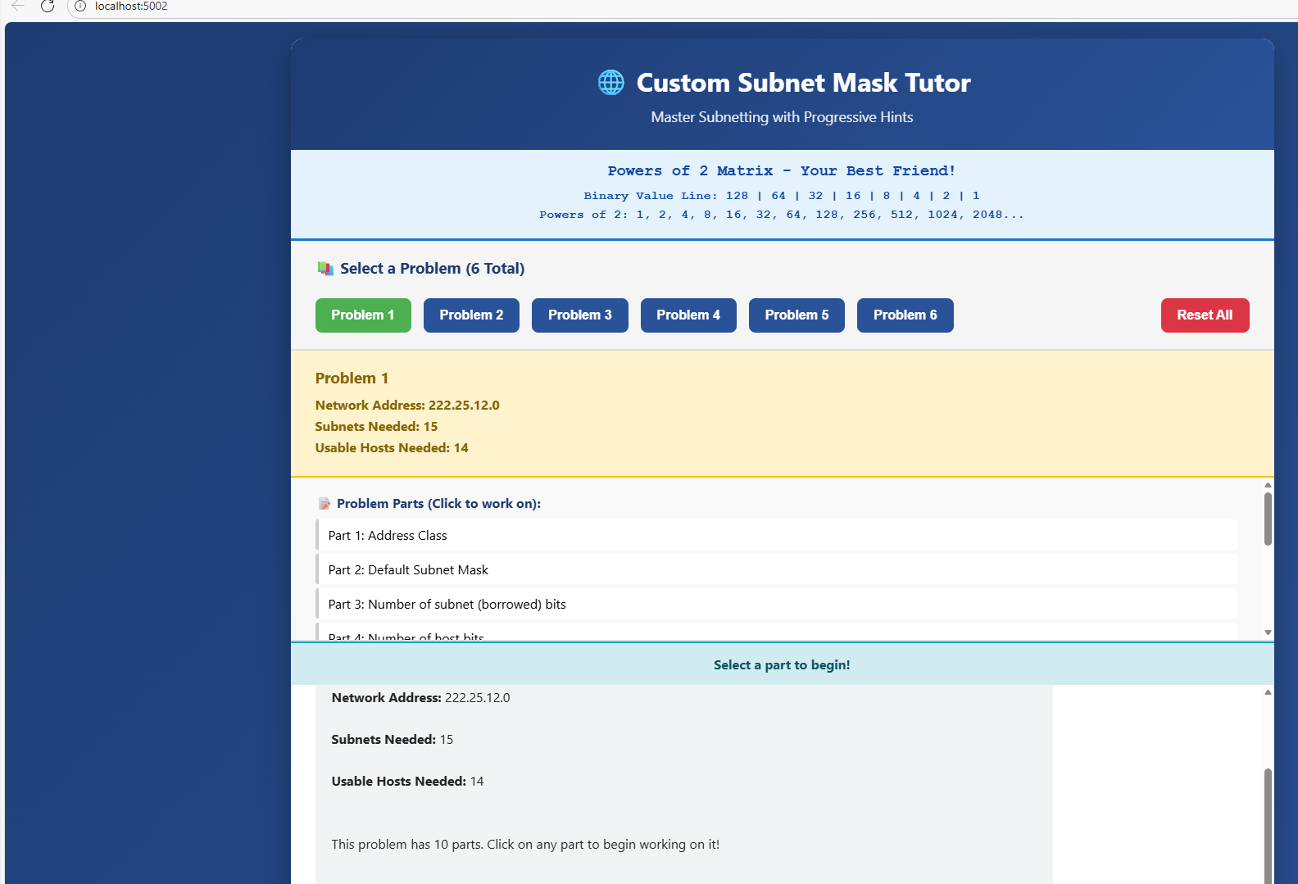
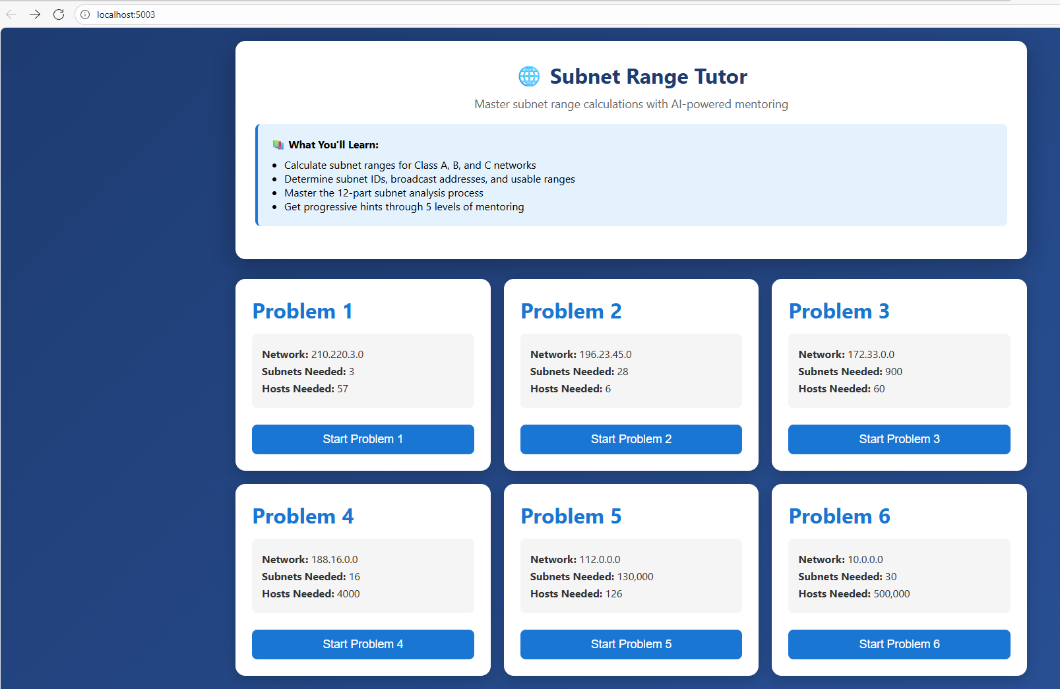
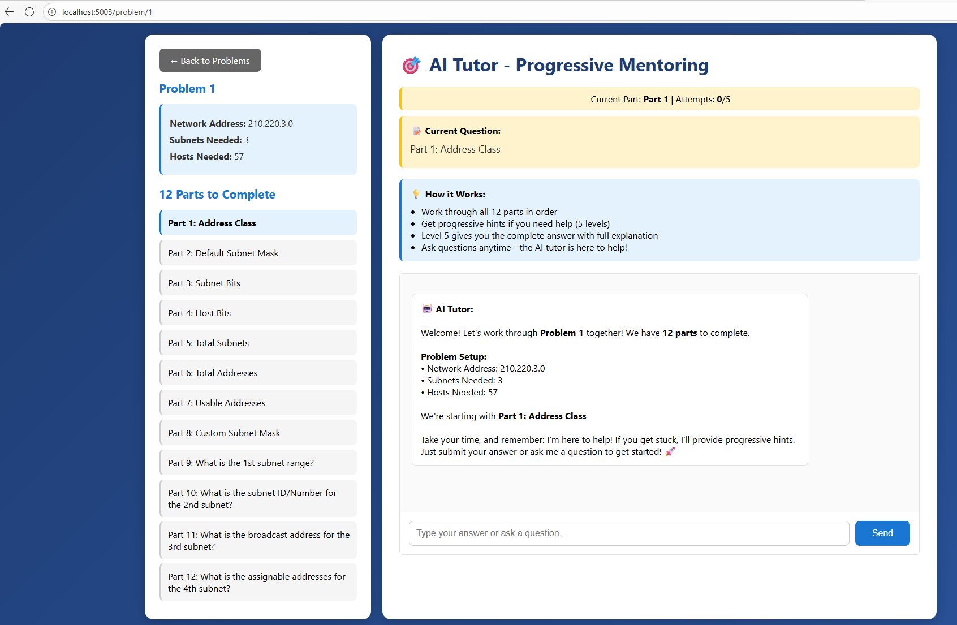
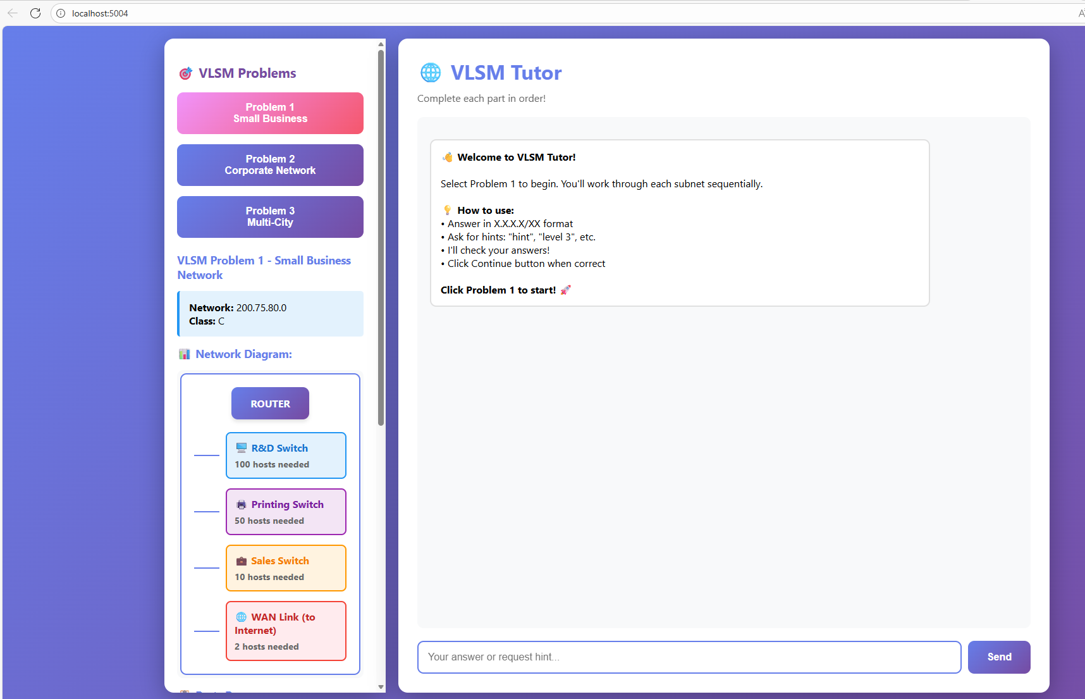

Don't have a "finished" project? That's okay. Submit what you have. Incomplete work with good documentation of what you tried is more valuable than nothing.
https://github.com/JoePhillippe/JoePhillippe/app_with_auth.py
Part 2: Your README
Create a README.md file in your project/ folder that answers:
https://github.com/JoePhillippe/JoePhillippe/ README.md

- What is this? (2-3 sentences explaining your project idea)
The bot agents tutor student for subnetting in NET-125.
- What does it do? (Or what was it supposed to do?)
The student use the agents to tutor them on the course subnetting quiz questions. The agent has five levels of help with the last level giving the answer and why the answer is correct. This is the same process I use for tutoring students.
- How far did you get? (Be honest — "70% there" or "just a prototype" is fine)
The project works when running on Spyder IDE and using localhost with ports.
I just started building the project to be hosted on Render.
- What AI tools did you use? (Gemini, Claude, ChatGPT, Copilot, etc.)
Claude
https://github.com/JoePhillippe/JoePhillippe/ README.md
Part 3: Your Reflection (The Important Part)
Create a file called REFLECTION.md in your project/ folder.
This is where you demonstrate what you actually learned this semester. Answer these questions thoughtfully:
I had not knowledge of using Claude to agents and Anthropic to run LLM. I understand the basics. Claude AI makes a lot of coding errors by not completing the Python code and html for Flask. My biggest learning curve is to build prompts to detail what I want do and why. I built each of the four agents in sprints which made them look different. When I tried to combine them, Claude AI could not create code to make them a single application. My next step is to learn “Render” so I know how to host the application.

